MATH 181.600

Instructor: Professor Ali Sayyad

Laith Yousef and Mohammad Mohammedtayib

**Average Speed Cameras & Speed Radars**

horizontal line

# 

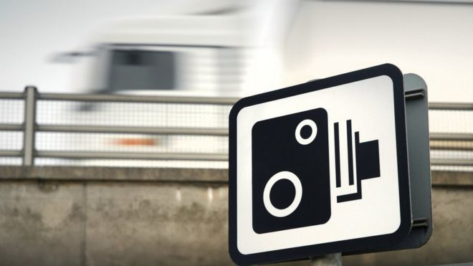

# 

Table of Contents

Introduction 3

Speed Detection Radars 3

* Figure 1.1…………………………………………………………………………………………………………………………………………………………………………………………..3

Average Speed Camera 5

* Figure 2.1……………………………………………………………………………………………………………………………………………………………………………………………5
* Figure 2.2……………………………………………………………………………………………………………………………………………………..……………………………………6

Python Code Index………………………………………………………………………………………………………………………………………………………………………………………..…8

* Figure 3.1………………………………………………………………………………………………………………………………………………………..…………………………………8
* Figure 3.2…………………………………………………………………………………………………………………………………………………………………………………………8
* Figure 3.3…………………………………………………………………………………………………………………………………………………………………………………………8
* Figure 3.4…………………………………………………………………………………………………………………………………………………………………………………………9
* Figure 3.5…………………………………………………………………………………………………………………………………………………………………………………………9
* Figure 3.6…………………………………………………………………………………………………………………………………………………………………………………………9

Works Cited……………………………………………………………………………………………………………………………………….…………………………………………………………….10

# 

# Introduction

You've probably been flashed for speeding by a radar and wondered what kind of range the radar was capable of capturing. Speed cameras come in a variety of options, ranging from average speed cameras to speed detecting radars. Differentiation, and rate of change will be used to prove the concept of radars and have a vitalization on how they function. The uniqueness of this topic is that it sheds light on the different types of radar cameras and how we overlook the complexity of machines that we see every day.

# Speed Detection Radars

Figure .1: Speed Detection Radar

The speeding radars that we usually see in the UAE streets are called speed detecting radars. The purpose of these radars are to detect the range and speed of vehicles. By generating a focused radio wave, the radar gadget detects echo. An object in the path of the radio wave will then reflect some of the electromagnetic energy, causing the radio wave to bounce back to the radar. When the wavelength of the frequency (radio waves) is shorter or takes a little longer to bounce back than what is encoded in the system, the radar camera will flash the over speeding vehicle to inform the driver that they have exceeded the speed limit and that a fine has been issued (Neltronics – How Does a Speed Camera or Radar Gun Work?, n.d.). Differentiation and integration are used to get the equations needed to calculate the range, in which the radar uses to detect the speed of vehicles.

* To begin, two basic equations are presented below: Equation 2 & Equation 3:

Equation 2

Equation 3

* Equation 2 is then substituted in Equation 3, resulting in Equation 4:

*equation 4*

* Equation 4 is then substituted into Equation 5, resulting in Equation 6:

Equation 5

Equation 6

* We will then derive Equation 6 to get the maximum range Equation:
* Effective aperture of the receiving Antenna
* Radar cross section of the target
* Power of minimum detectable signal
* and the Peak power transmitted by the Radar

*(Radar Systems - Range Equation, n.d.).*

# Average Speed Camera

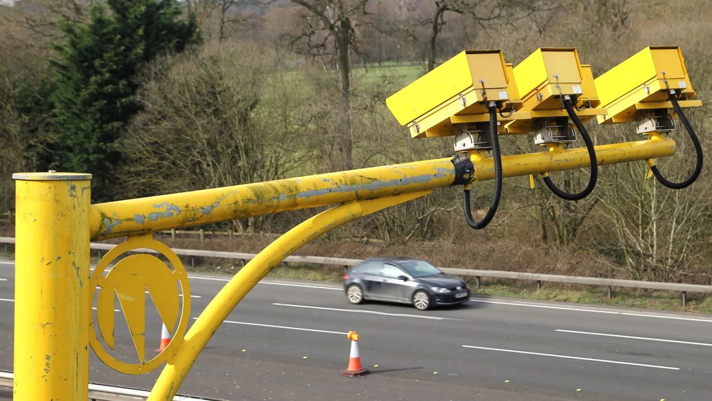

.

Figure .1: Average Speed Camera

The average speed cameras are commonly found in Europe and Australia, it was invented by Maus Gatsonides for the purpose of timing his laps while driving his formula car. Average Speed Cameras consist of two different cameras “entry head” and “exit head”. Entry heads collects vehicle data such as your license plate and speed. Exit heads collects data as well as calculates the average speed of the vehicles resulting in a fine of over speeding (Soole et al., 2013).

* Average Speed
* Distance
* Time

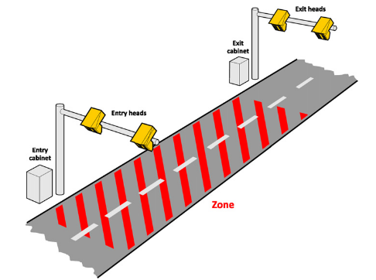

Figure 2.2: Illustration of average speed camera (Entry & Exit head)

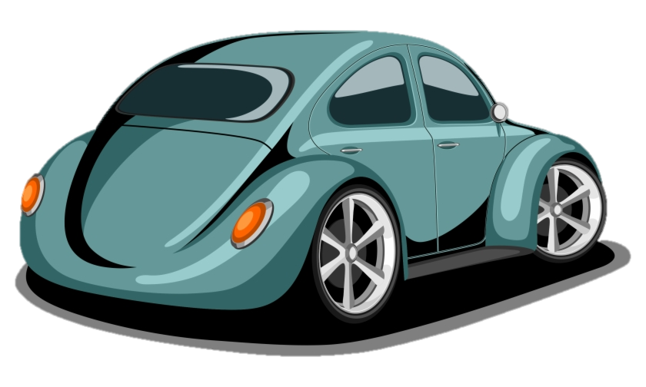

The speed limit we will be using for the report is 80 m/s (288 km/h) and the maximum range of distance is 214.15 m (0.21415 km).

**Question:**

a) How long does it take to cover 214.15 meters while going on the speed limit from (Position A) to (Position B)?

b) what is the speed of a vehicle going 50 m/s at (Position A), the time it took the Vehicle to reach (Position B) is 2.67 seconds

Ans)

**Python Code Index**

**Code Brief:** With the help of python, we will be able to mimic the average speed and speed detection radars, and the code will be able to track and save vehicle IDs and speed by utilizing the average speed equation.

* A screenshot of a computer

  Description automatically generatedTo begin with, tracking vehicles is a vital component of a radar in order to identify different vehicles from each other (Figure 3.1).

Figure .1: Object Tracking

* A screenshot of a computer

  Description automatically generatedDisplaying horizontal lines to determine the start and end point of the range (Figure 3.2).

Figure 3.2: Displaying the lines

* A screenshot of a computer

  Description automatically generated with medium confidenceSpeed limit is essential to determine the maximum speed a vehicle can go (Figure 3.3).

Figure 3.3: Speed limit

* Saving the vehicles data and speed will be made through a txt file that will be created automatically (Figure 3.4).

Figure 3.4: Collecting vehicles data

* Figure 3.5 calculates the time taken to cross the defined range between the two lines and captures the over speed vehicle after crossing the second horizontal line

Figure 3.5: Calculation of time and capturing over speeding vehicles

* After encoding all of the above, we can then use the average speed formula to detect the final speed of the vehicles (Figure 3.6).

Figure 3.6: Average speed

Works Cited

Carbuyer. (2021, July 23). *Average speed cameras: how do they work?* [Photograph]. Carbuyer. <https://www.carbuyer.co.uk/tips-and-advice/160228/average-speed-cameras-how-do-they-work>.

Dallal, S. (2014, March 8). *Abu Dhabi radar traps aim to cut speed and increase safety on roads* [Photograph]. The National. <https://www.thenationalnews.com/uae/abu-dhabi-radar-traps-aim-to-cut-speed-and-increase-safety-on-roads-1.451115>.

*Neltronics – How does a Speed Camera or Radar Gun work?* (n.d.). Neltronics. Retrieved March 19, 2022, from <https://www.neltronics.com.au/how-does-a-speed-camera-or-radar-gun-work/>.

*Radar Systems - Range Equation*. (n.d.). Tutorialspoint. Retrieved March 19, 2022, from <https://www.tutorialspoint.com/radar_systems/radar_systems_range_equation.htm>.

Soole, D. W., Watson, B. C., & Fleiter, J. J. (2013). Effects of average speed enforcement on speed compliance and crashes: A review of the literature. *Accident Analysis & Prevention*, *54*, 46–56. <https://doi.org/10.1016/j.aap.2013.01.018>.

*Wales’ top speed camera snaps 8,400 offences in 2016*. (2017, May 12). [Photograph]. BBC News. <https://www.bbc.com/news/uk-wales-39871640>.